PGR Supervisor’s Guide - Nomination of Examiners

Approval of Final Title and Nomination of Examiners
- Approximately three months prior to your student’s thesis submission deadline, you and your student need to complete the Approval of Title and Nomination of Examiners online forms.
Overview of the process
- Student submits final title and abstract.
- Supervisor nominates examiners
- Head of School approval
- PG Dean approval

- Your student needs to make their online submission first, including uploading an abstract; to initiate the process.
- You will be submitting your form on behalf of the Supervisory Team (usually completed by the ‘Main’ Supervisor, but can be done by any supervisor).
- The online supervisors’ form includes nominating examiners and providing evidence of their suitability in relation to examining the thesis. Usually an internal and an external examiner will be appointed. For staff candidates, two external examiners are appointed (for junior members of staff, at the discretion of the Dean of Postgraduate Studies, one external and one internal may be appointed). You should discuss the examiners with the student before completing the form. For full detail on procedures and requirements please see the Student Progress Website.
- These forms then go to Head of School & PG Dean for approval.
- You can monitor progress via the ‘Summary’ tab (see below).

How to access the Nomination of Examiners Forms
In portfolio click on the PGR CoP icon to access the Code of Practice Website,
Your ‘Dashboard’ will show any outstanding forms. Click on the number to view the list of students with forms due (alternately the dashboard page also shows a list of PGRs for whom you are supervisor and you can click on a specific student).
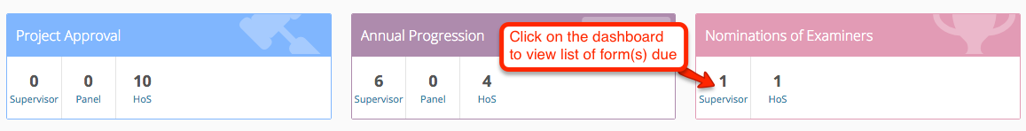

Completing the Supervisors’ form
From the list of students click on the ‘Edit Supervisor’ link.
You can first view the student’s submission – by clicking on the ‘Student’ tab (see below). Use the ‘Supervisor’ tab to view and complete the form.
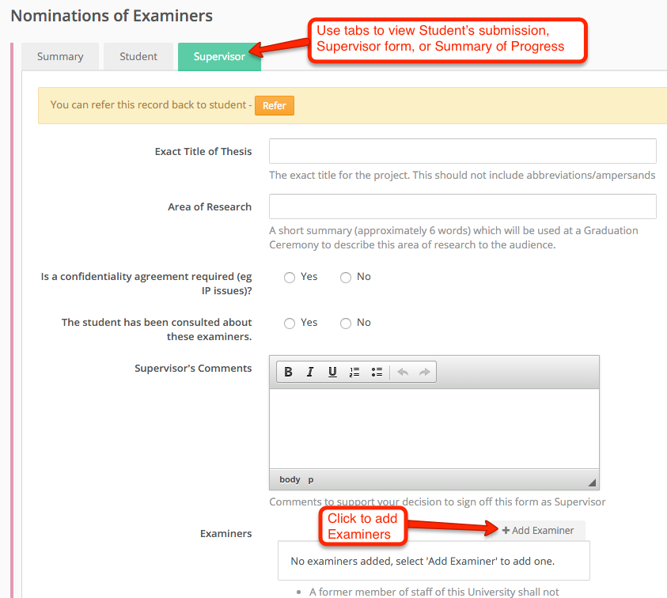
Complete the form and Click on “+Add Examiner” to add the desired examiners. This brings up a pop-up with separate tabs for adding University and External examiners. Note: you can upload a CV or other document after adding the examiners (see below).

Adding an Internal Examiner
Under the “University” tab search for a member of staff by typing in their surname, click on search then click the green tick to add them:
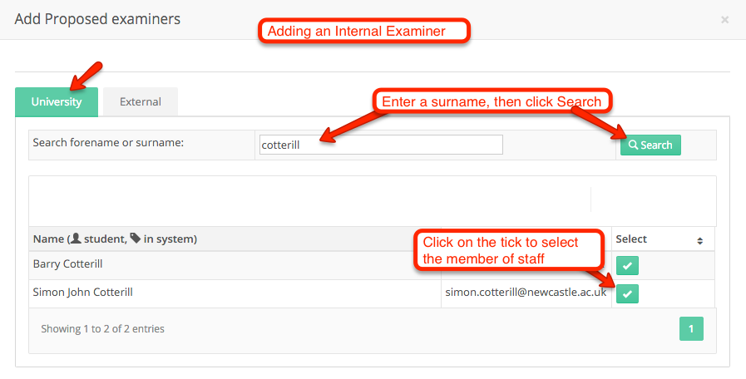

Adding an external examiner
Under the “External” tab enter the required details and then save by clicking on the “Add Examiner” button.
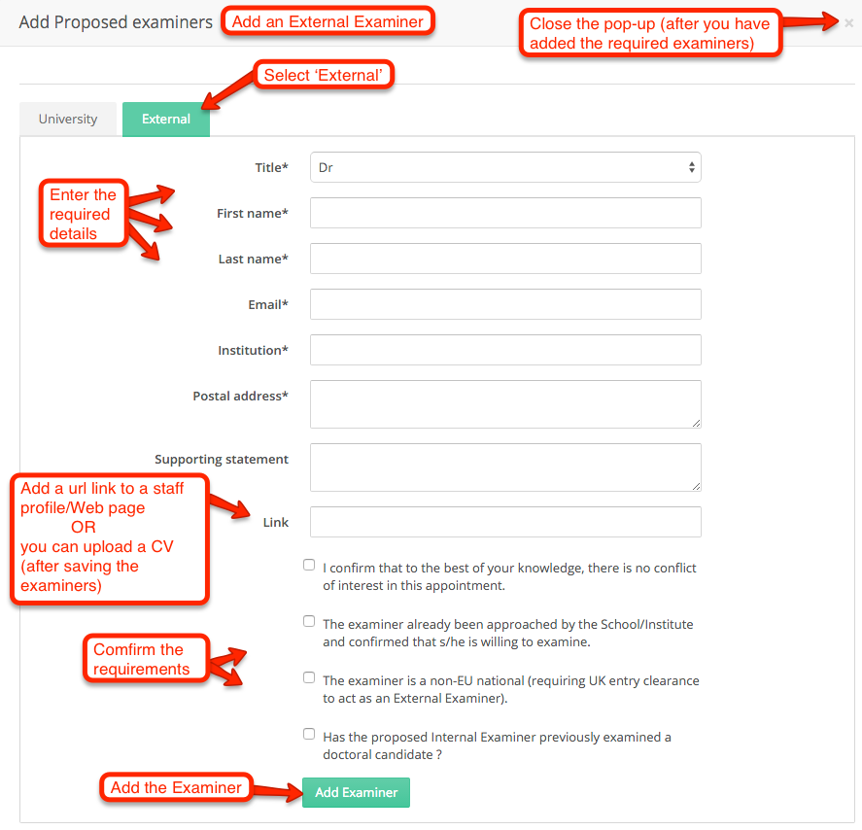
Once you have added all the Examiners close the pop-up and your form will be updated.

Ensure you Save or submit your form (see below).

Continued…

Editing Examiner details / uploading a CV
You can edit the details for a specific Examiner by clicking on their name. This includes the facility to upload a CV or other supporting documents. You should either upload a CV and/or include a link to an online staff profile or Website:
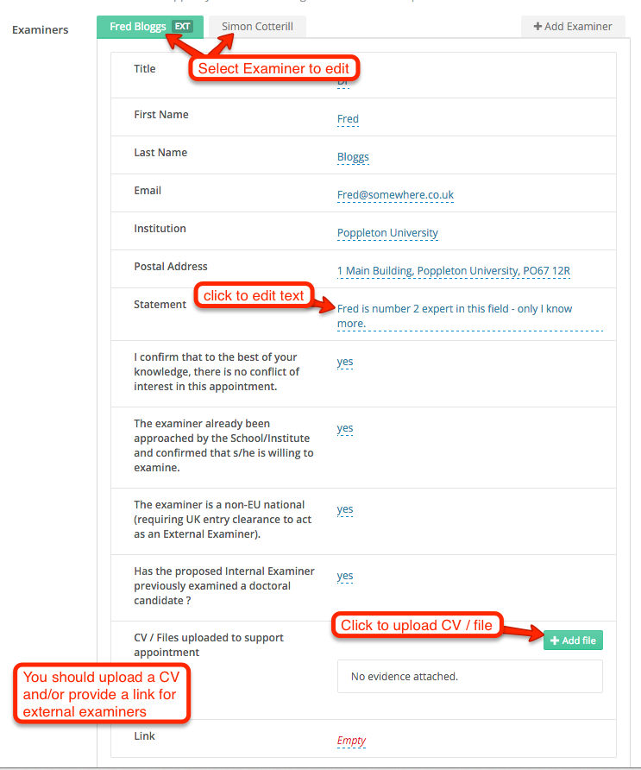

Submitting your completed form
Use the Save button if you want to come back and complete the form later.
Once you have completed the form use “Confirm and Submit”, which submits to Head of School or their nominee.

