PGR Administrator’s Guide - Nomination of Examiners

Approval of Final Title and Nomination of Examiners
The Nomination of Examiners process is now integrated into the PGR CoP Website and uses the same Lists, Filters, Dashboard and Admin tools as Progression and Project Approval (see the PGR Cop Admin Guide for details of how to use these features). Students and Supervisors normally access via ePortfolio, but administrators can access PGR CoP directly at: https://postgrad.ncl.ac.uk/
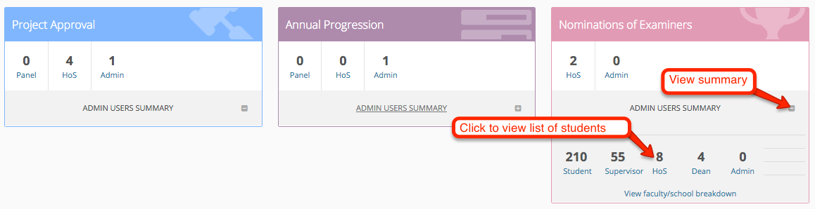
Privileges for Nominations are now the same as for Progression/Project Approval and are managed by RSST/Graduate School.
Supporting Features
The PGR Website now includes students’ start and end dates, the end date (submission deadline) being important in determining when the Nominations process should happen:
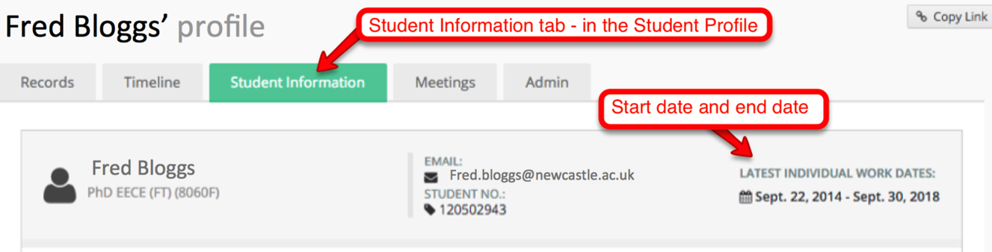
The Reports menu now includes a way to list and filter students by a range of start and end dates based on the information from SAP Individual Work:
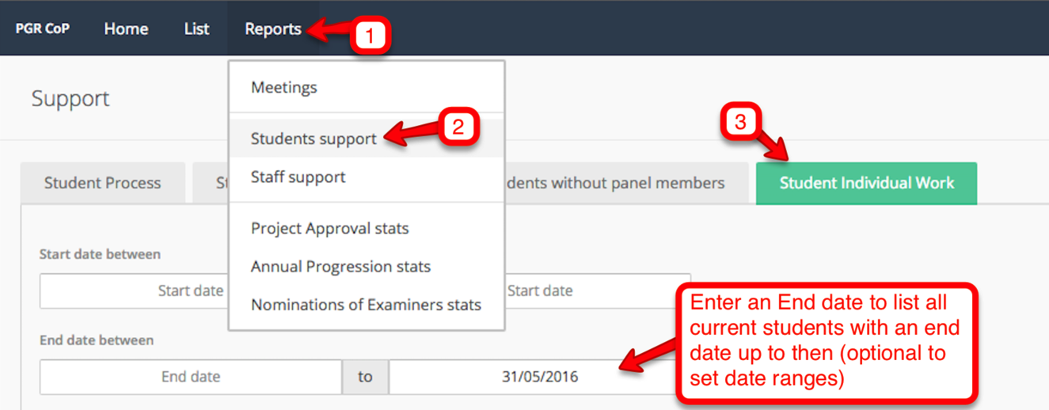

Administrative Tools

Editing Examiners Information
In the ‘Admin’ section of the student profile choose ‘add/edit examiners’.
Note: currently School/Institute administrators can upload a file/CV and modify the Link to a Web profile. RSST/Graduate school administrators have the additional privileges of being able to add new examiners and edit all fields.
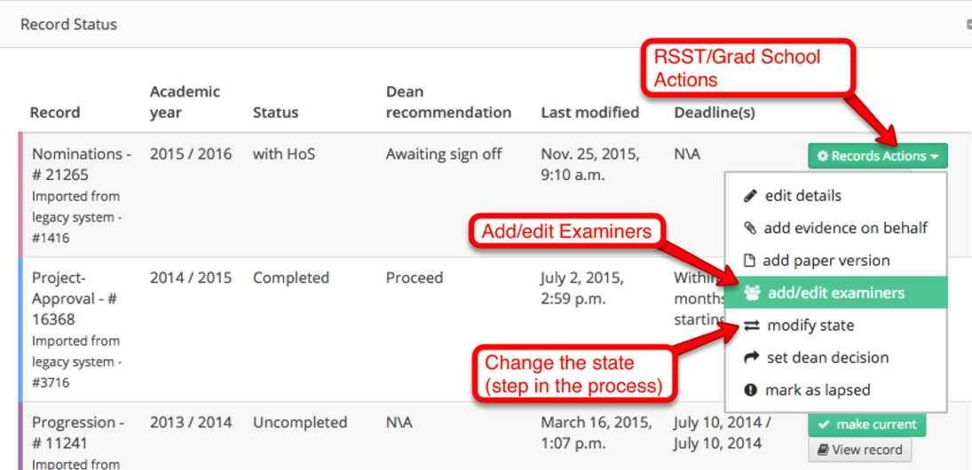

Editing Examiner details / uploading a CV

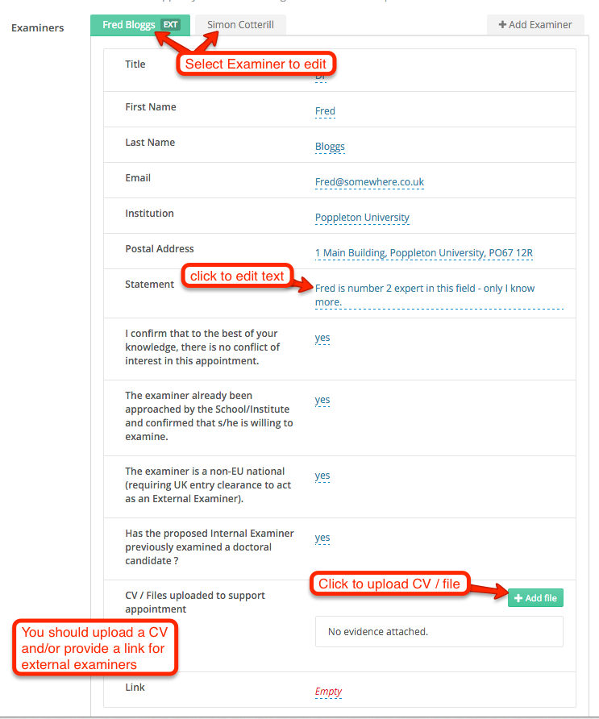
Click on “+Add Examiner” to add the desired examiners (Grad. School Admins only). This brings up a pop-up with separate tabs for adding University and External examiners; you can upload a CV or other document after adding the examiners (see above).

Removing an Examiner
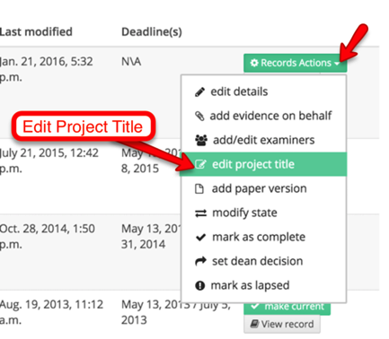
Using “Edit/Add Examiner” from the menu (see above) click on Any removed examiners are listed and can be re-instated by selecting:

Editing the final title of the thesis
This option is only available to Graduate School when Nomination records are at the Dean stage, with Admin or completed. The facility is intended for use where a minor grammatical or spelling error needs correcting.

Overview of the Nominations Process
Overview of the process
- Student submits final title and abstract.
- Supervisor nominates examiners
- Head of School approval
- PG Dean approval

Timing
- Approximately three months prior to a student’s thesis submission deadline, the student and supervisor need to complete the Approval of Title and Nomination of Examiners online forms.

Student Submission
- The online process is normally initiated by the student (you may need to prompt them!). However, if desired you have the option to set student and supervisor deadlines.
- The student form includes their exact final title and they must upload an abstract.
- On submission the student is sent a confirmation notification cc’d to the supervisors – to prompt them to complete their step.

Supervisor Submission
- This will be submitted on behalf of the Supervisory Team (usually completed by the ‘Main’ Supervisor, but can be done by any supervisor).
- The supervisor can view the student form and has the option to refer back.
- The online supervisors’ form includes nominating examiners and providing evidence of their suitability in relation to examining the thesis. Usually an internal and an external examiner will be appointed. For staff candidates, two external examiners are appointed (for junior members of staff, at the discretion of the Dean of Postgraduate Studies, one external and one internal may be appointed). You should discuss the examiners with the student before completing the form. For full detail on procedures and requirements please see the Student Progress Website.

Head of School Stage
- These forms then go to Head of School / nominee for checking. They can add a comment.

PG Dean Sign-off
- The Dean sets a decision (‘Proceed’ or ‘Do not proceed'). The student is notified if the decision is Proceed. In the unlikely event ‘Do not proceed’ is select the record moves to ‘With Admin’ for further action.

Refer Backs
- All parties from supervisor onwards can refer back one step in the process (a policy set for all PGR CoP online processes) and provide text to specify the reason for this. RSST/GS can change to any step in the process if there exceptional circumstances.

