## What is Annual Progression?

It is a University requirement that students registered on postgraduate research programmes undergo the Annual Progression process. A report from the supervisory team, along with the student’s report and supporting evidence, will be considered by a School Progress Panel. The panel makes a recommendation on progression to the Head of School and Postgraduate Dean for their formal approval. A simplified overview of the process is provided in Figure 1.

Figure 1. Simplified Overview of Progression

Flow diagram for Annual Progression. Student report, evidence and training information and Supervisor Report are submitted (either can be submitted first). Next step is Panel, then School feedback, and final step is Dean's decision.

*Note:* the student and supervisor forms can be completed independently. It is optional for students to share their submission with supervisors (University policy).

You can find the full guidelines online at the Student Progress Service Website: <https://newcastle.sharepoint.com/hub/sp/Pages/progression.aspx/>

## The Online Submission Process

You will receive an Email with the deadline for submitting a Progression form for your student’s Annual Progression, which will include a direct link to the form. Alternatively, you can access this via the PGR Code of Practice system (PGR CoP) <https://postgrad.ncl.ac.uk>. Use your usual University username and password.

From the home page of PGR CoP you will see a ‘dashboard’ indicating if there are any outstanding forms for you to complete in your role as supervisor for Annual Progression, Project Approval or Nomination of Examiners. If applicable, you will also see outstanding tasks if you are a panel member of Head of School/nominee.

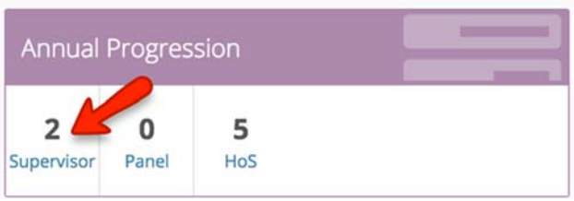

Below this, you will also be presented with a list of students that you supervise, and within their information boxes will be listed any students currently awaiting your input.

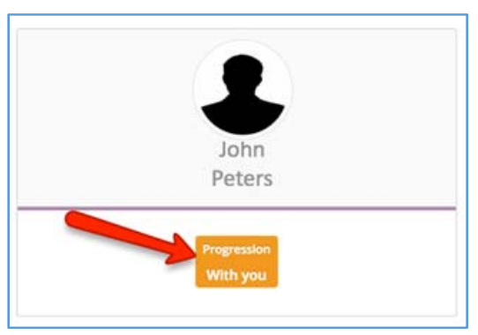

### Access the records

You can access a particular student’s record in one of two ways:

1. By selecting them from the list of your supervisees.
2. By selecting the number of students with you in the Annual Progression box. This will show a list of all students currently with you for comment, and you will then need to select them from this list.

### Complete the Annual Report form

Screenshot - Edit supervisor form button

Once you have accessed your student’s profile, follow the ‘Edit supervisor form’ button Use the tabs across the top to switch between the Summary, Student (*if they have granted permission for you to view it*), and Supervisor’s form.

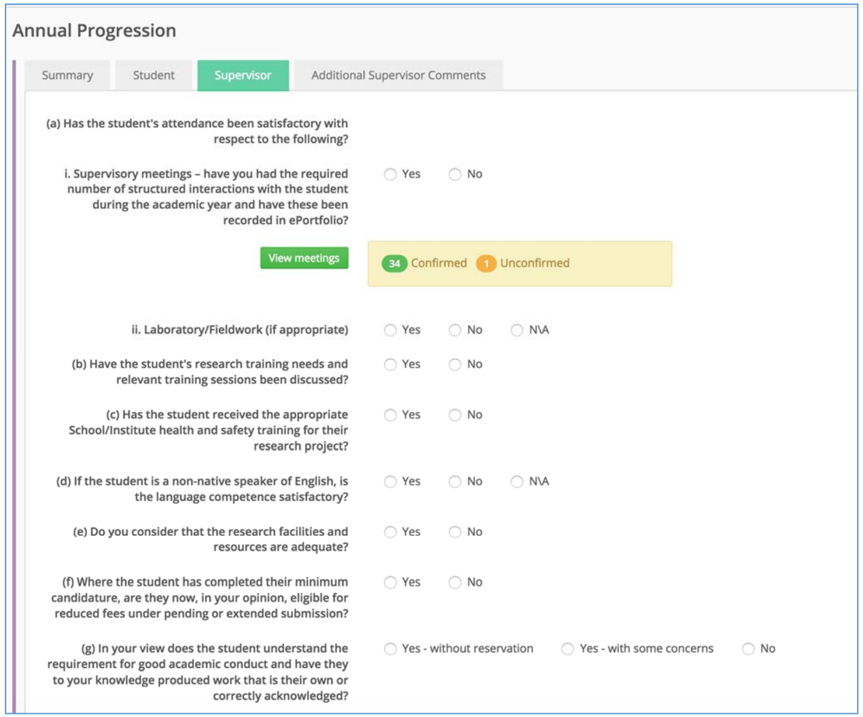

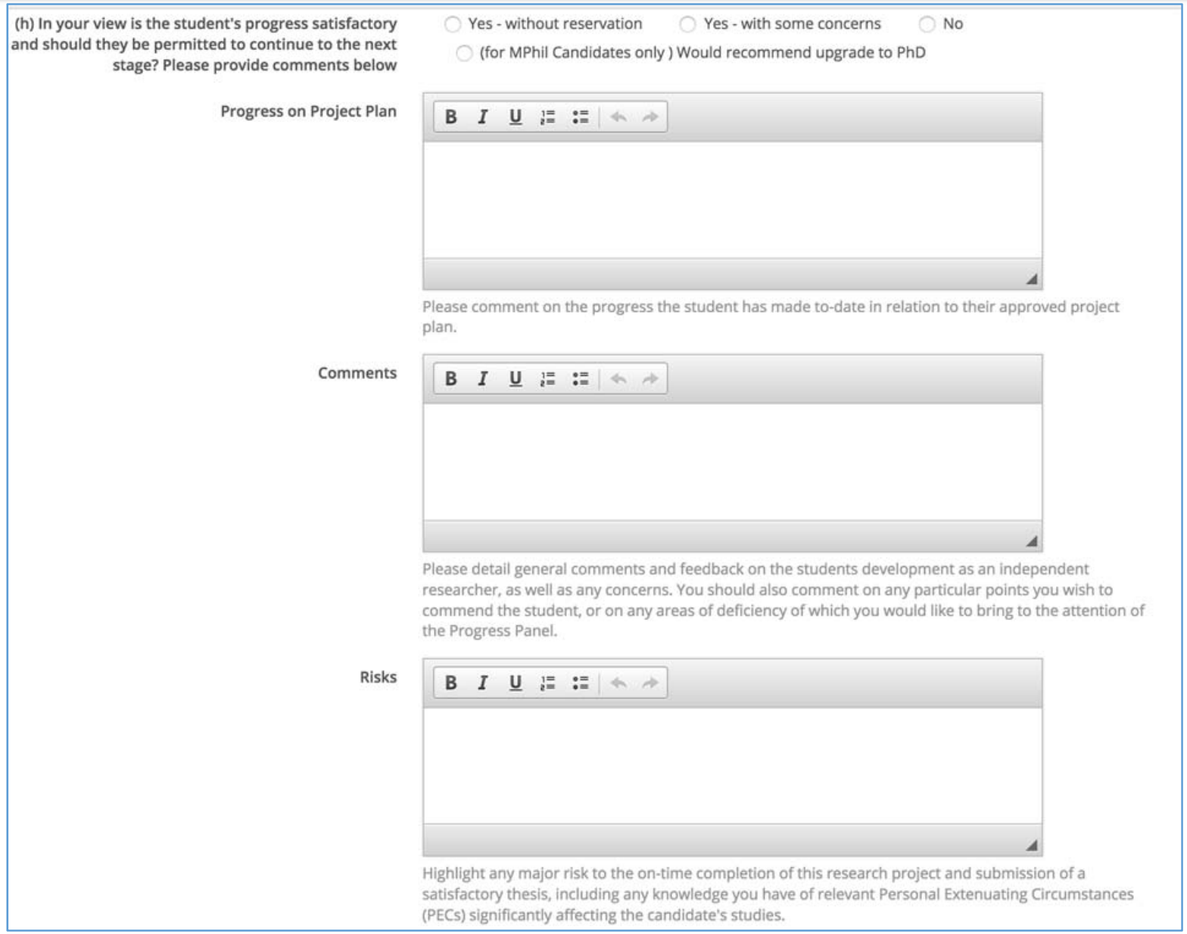

Complete all questions as appropriate. Use the ‘**Save**’ button to save your entry and return to it later.

### Submit the form

Once you and any other supervisors have fully and properly completed the form, use the ‘Confirm & Submit’ button to finally submit your feedback. **Remember you are submitting on behalf of the supervisory team!**

### Additional Supervisors Comments

There is an *optional* facility for other members of the supervisory team to add additional comments. This is done via the tab labelled ‘Additional Supervisor’s Comments’. There is no need to enter comments from the main supervisor form again.

Supervisors can make as many comments as they wish, until the panel meet.

*Remember*: the Supervisor form and additional supervisor’s comments will be visible to the student after sign-off by the Dean. There is no opt-out (University policy), taking into account that any problems should have already been raised with the student. In contrast, sharing of the student form is opt-in (University policy), to give the student an opportunity to raise confidential concerns with the panel, reflecting the different ‘power relationship’.

### Additional features of the Website

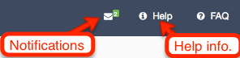

In the Notifications section you can see all the messages sent to you from this system. There is also online context sensitive help.

### Student Profile

The profile for each of your students includes:

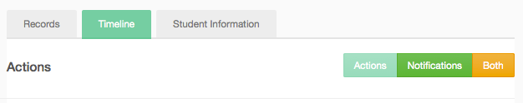

**Records** – a list of records relating to Project Approval, Annual Progression and Nomination of Examiners.

**Timeline** – a chronological list of actions (dates of submissions for student, supervisors, panel, HoS etc) and you can also see notifications.

**Student Information** – including registration information from SAP SLcM (this data will be at least one day behind, with automated updated in the evenings of working days).

## Further Information

Progression Guidelines:  
<https://newcastle.sharepoint.com/hub/sp/Pages/progression.aspx>

See also the inline help or view instructions at:  
<https://reflect.ncl.ac.uk/help/pgr>

For questions about requirements and procedures please contact your School or Research Student Support Team /Graduate School.

HASS / SaGE: [gradschool@ncl.ac.uk](mailto:gradschool@ncl.ac.uk)

FMS: [medpg-enquiries@ncl.ac.uk](mailto:medpg-enquiries@ncl.ac.uk)

For technical problems please contact IT Service Desk:   
[it.servicedesk@ncl.ac.uk](mailto://it.servicedesk@ncl.ac.uk) or tel. (0191 222) 85999