# Postgraduate Students’ Guide to Submitting Annual Reports Online

## What is Annual Progression?

It is a University requirement that students registered on postgraduate research programmes submit a report as part of the Annual Progression process. This report, along with your supporting evidence plus a report from your supervisor(s), will be considered by a School Progress Panel. The panel makes a recommendation on your progression to your Head of School and Postgraduate Dean for their formal approval. A simplified overview of the process is provided in Figure 1.

Figure 1. Simplified Overview of Progression

Flow diagram for Annual Progression. Student report, evidence and training information and Supervisor Report are submitted (either can be submitted first). Next step is Panel, then School feedback, and final step is Dean's decision.

Your School will provide you with guidance on what you need to submit. This could involve one or more of the following; a written progress report; a project presentation; a piece of academic writing or a viva by the panel. Students should also provide copies of their ‘Training Needs Analysis and PDP’ and list of ‘Training Courses Attended’.

You can find the full guidelines online at the Student Progress website: <https://newcastle.sharepoint.com/hub/sp/Pages/progression.aspx>

## The Online Submission Process

Once you have received an email detailing the deadline and you have prepared your Progress Report and other evidence, you can submit it electronically. The Email includes a direct link to your Annual Progroession form. Alternatively you can access it via the PGR Code of Practice Website: <https://postgrad.ncl.ac.uk>. Log on with your usual University username and password[1].

Then follow the simple steps below:

### Select the “Annual Progression” tab

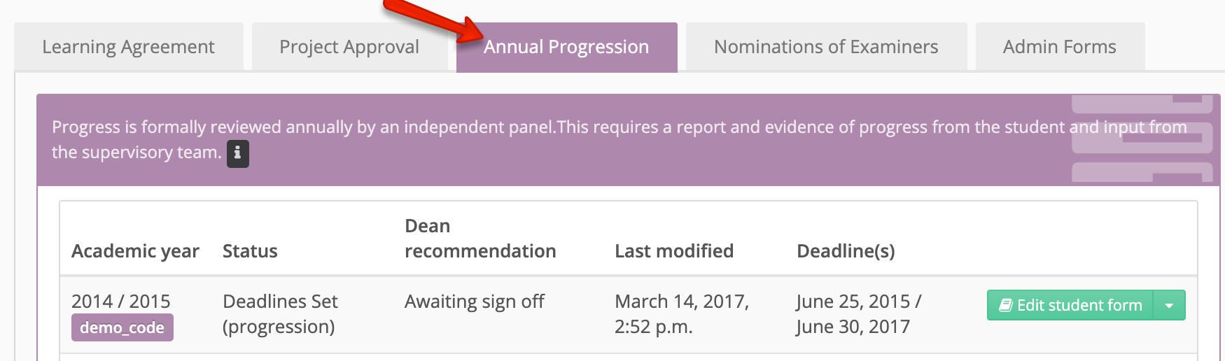

Note: if you are expecting to complete your Annual Progression soon, but no deadline has been set, contact your school in the first instance.

### Complete the Annual Progression Form.

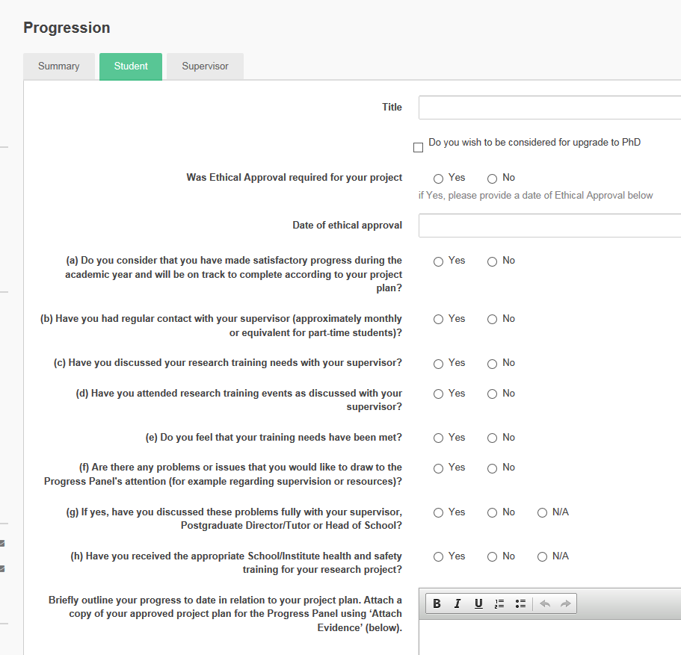

You have the option to share your submission with your supervisors, but are not obliged to do so.

### Add your evidence.

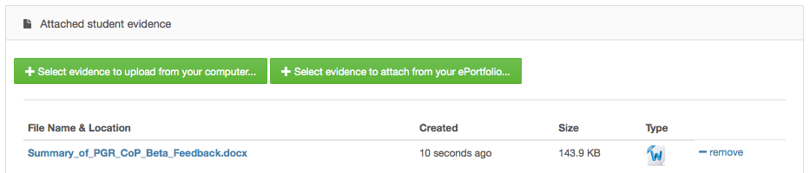

Upload file(s) from your computer, and/or attach evidence from NU Reflect – including Self Assessment and PDP(s).

### Confirm & Submit.

Screenshot of the Save button and the Confirm and Submit button

Use the ‘**Save**’ button if you need to come back later to add more information.

Use the ‘**Confirm & Submit’** button when you have finished and are ready to submit your finished report.

You can also use the ‘Summary’ tab to see the stage your submission is at e.g. with the Panel, Head of School (HoS) or Dean.

The ‘Supervisor’ tab shows your Supervisor’s submission if this has been completed yet.

## Further Information

Progression Guidelines:

<https://newcastle.sharepoint.com/hub/sp/Pages/progression.aspx>

See also the inline help and FAQ or view instructions at:

<https://reflect.ncl.ac.uk/help/pgr>

For questions about requirements and procedures please contact

your School/Graduate School.

Graduate School (Faculty of HaSS and SAgE)

[gradschool@ncl.ac.uk](mailto:gradschool@ncl.ac.uk)

Graduate School (Faculty of Medical Sciences)

[medpg-enquiries@ncl.ac.uk](mailto:medpg-enquiries@ncl.ac.uk)

For technical problems please contact IT Service Desk:

[it.servicedesk@ncl.ac.uk](mailto://it.servicedesk@ncl.ac.uk) or tel. (0191 222) 85999

# eProgression FAQ (Frequently Asked Questions)

### Can I complete my form on my home computer?

Yes, *if* your computer is connected to the Internet. The ePortfolio can be accessed using a Web browser from *any* location that has Internet access. <https://postgrad.ncl.ac.uk/>

### How much evidence should I include?

Your School will provide you with guidance on what you need to submit. This could involve one or more of the following; a written progress report; a project presentation; a piece of academic writing or a viva by the panel. Students (at least 1st & 2nd years) should also provide copies of their ‘Self Assessment and PDP’ and list of ‘Training Courses Attended’ from their ePortfolio.

Think carefully about what you want to include. Remember it is quality not quantity that counts! It will help your Panel if you include an informative title and brief description of why each item of evidence will help support your progression. Do include ‘Courses’; this will list all the workshops and conferences that you have recorded in your CV. See the guidelines on the Student Progression Website for further information. <http://www.ncl.ac.uk/students/progress/staff-resources/pg-research/progression.htm>

### Can I complete the form and add evidence over a number of days before submitting the report?

*Yes.* You can fill in the form and add evidence, save and re-save over a number of days – but don’t forget to submit it before the deadline!

### Can I ‘Cut and Paste’ information from Word documents into the Annual report form?

Yes, this can sometimes save time and let you check spellings. However, only copy simple text. Do not include diagrams, images, tables or other special formatting as this may potentially cause problems displaying the information to your Panel. Diagrams, tables etc. can be included in documents which you can upload into the ‘Evidence’ area of the Progression system.

### What if I miss my deadline or no deadline has been set?

Contact your School Administrator or Graduate School as soon as possible.

1. Staff candidates should log in with their student, rather than staff accounts.