eProgression – Guide for Heads of School

The Online Submission Process

Log into the system
Following Panel submission you will receive an email requesting you to complete the Head of School report for a student’s Annual Progression, which will include a direct link to the form. Alternatively you can access this at https://postgrad.ncl.ac.uk or via the ‘PGR Annual Progression’ link in ePortfolio. Use your usual campus username and password to log in.
From the home page you will see if there are any outstanding progressions for you to complete in your role as Head of School. If applicable, you will also see outstanding tasks if you are a supervisor or Head of School.
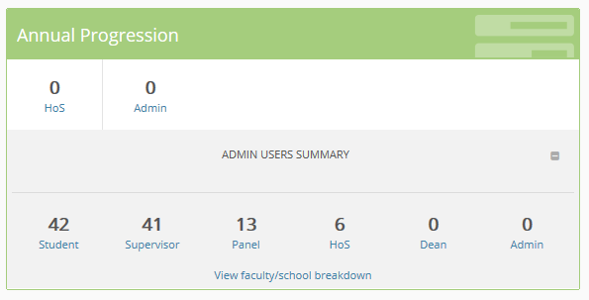
In addition, you will see a summary of the school, and can access records from these options as well as those in the white space relevant directly to you.

View the records
Select the box ‘HoS’ box in the top row of the Annual Progression box. This will show a pre-filtered list of all students awaiting your approval.
Use the ‘view records’ link against the progression item to view a summary of the progression. If the panel have completed their forms, then you will be able to view the details submitted by them. If they remain outstanding, then you will unable to view them.

Completing the progression report
Add your comments to the box. Use the ‘Save’ button to save your entry and return to it later.
Alternatively, use the ‘Refer’ button to refer it back to panel.

Submit the form
Once you have fully and properly completed the form, use the ‘Confirm & Submit’ button to finally submit your feedback.

Additional features of the Website
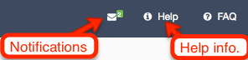
In the Notifications section you can see all the messages sent to you from this system. There is also online context sensitive help.

Student Profile
The profile for each of your students includes:
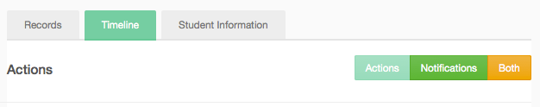
- Records – a list of records relating to Project Approval, Annual Progression and Nomination of Examiners.
- Timeline – a chronological list of actions (dates of submissions for student, supervisors, panel, HoS etc) and you can also see notifications.
- Student Information – including registration information from SAP SLcM (this data will be at least one day behind, with automated updated in the evenings of working days).

Further Information
You will may have access to the Admin functions. Please refer to that guide for more details.
Progression Guidelines:
http://www.ncl.ac.uk/students/progress/staff-resources/pg-research/progression.htm
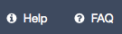
See also the inline help and FAQ or view instructions at:
https://portfolio.ncl.ac.uk/help/faq/progression/
For questions about requirements and procedures please contact your School/Graduate School.
For technical problems please contact IT Service Desk:
it.servicedesk@ncl.ac.uk or tel. (0191 222) 85999

