

Tutor Meetings

As of the 2017-18 academic year, for undergraduate students, tutors should record the first meetings that are offered and those that have taken place in ePortfolio. For taught postgraduates, tutors should record the offer of meetings in ePortfolio. The reasons why they have not taken place should also be recorded.

Please note, however, that provided a tutor offers a meeting within ePortfolio using meeting slots, if a student chooses not to pick a time to meet the tutors this can be regarded as sufficient reason why the meeting has not taken place. Only if a meeting slot is not created within ePortfolio should a reason be recorded elsewhere why a meeting has not taken place.

There are several ways to record / offer meetings with tutees in ePortfolio.



One method is to select the “Meeting” text underneath the student’s image on the front page of ePortfolio.

The link will take you to the form below.

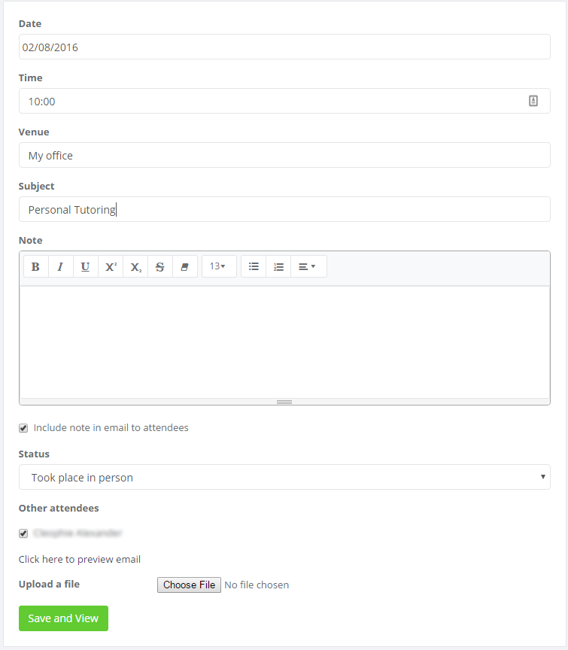

Retrospective Recording of Meetings

In this form complete the date, time, venue, subject of meeting, and add any relevant notes or documents. You will notice that the tutee’s name is listed in the meeting as an “other attendee”. As this is a meeting that has already taken place, set the status of the meeting to either “Took place in person”, “Took place at a distance” or “Did not take place at all”.

Save and view to complete the meeting record. The student will receive an email informing them that they have been added to a meeting. You can select the link to preview the email, and tick the relevant box to add the initial note into the content of the email.

N.B. If you have set up the meetings using “Meeting Slots”, the meeting record will automatically be created. You do not have to retrospectively record the meeting as well.

Offer of a meeting

If you follow the same process as above but choose a date in the future, you will be making an offer of a meeting to the student. A very similar form will appear but you won’t be able to assign the status of the meeting as it will not have taken place yet.

The student will be sent an email inviting them to the meeting. The student will have the opportunity to decline this offer, but if they don't it will be assumed they have accepted. A meeting record will be created to which all attendees will be able to add notes, before and after the meeting.

Other method to record meetings

Another is to choose the Add Meeting graphic at the top left hand side of your homepage.



The form will appear but there are no attendees show. Fill out the form and save it. Add attendees using the Add/Remove attendees option. This is described in further detail in the “Group Meetings “section.

Group Meetings

To create a group meeting, from the homepage (or Meetings section) select Add Meeting.

In this form complete the date, time, venue, subject of meeting, and add any relevant notes or documents. Any notes or files that are uploaded will be visible by all attendees of the meeting.

Save the meeting record.



Once the meeting record has been saved, add your attendees by selecting “Add / Remove Attendees”.

A pop-up box will appear with a search box and a list of ‘recommended’ people to add to the meeting. Your tutees will be in this list of recommended people.

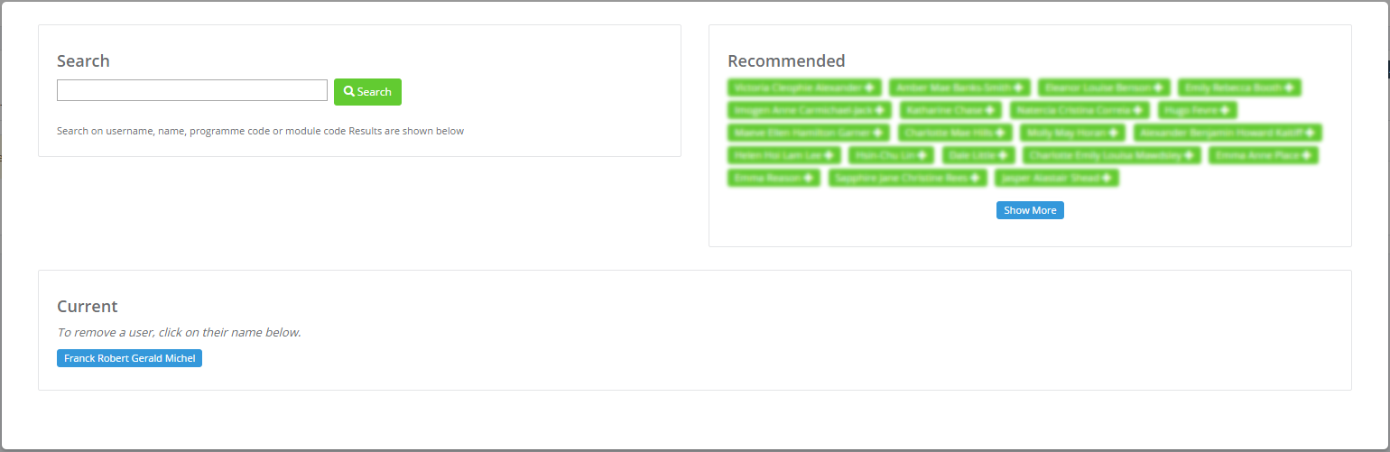

Once the meeting has passed you can use the sliders in the Attendees box to mark any students that did not attend.

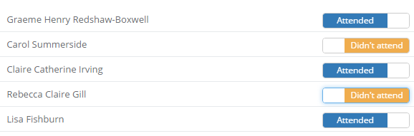

Adding Notes

The tutor and tutee can add notes before and after the meeting. You may wish to record the meeting outcomes. To do this, go into the meeting record through the Meetings section.

Click Add Note.

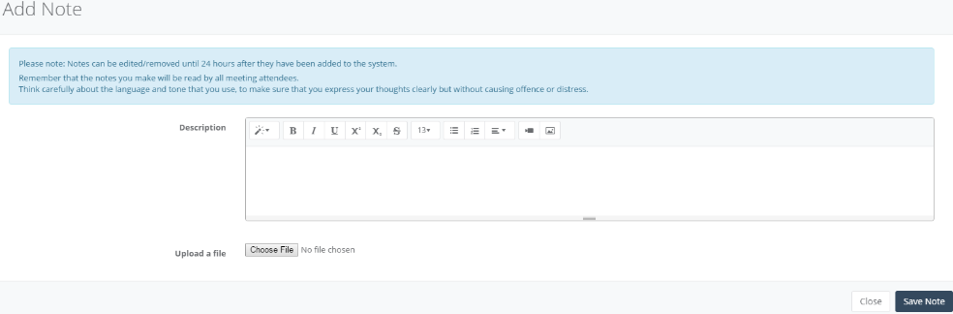Fill in the details in the note. Any note that is added to a meeting will be visible by all meeting attendees.

Notes are locked after 24 hours, and added to a notification email. New notes can still be added to meeting records.

Meeting slots

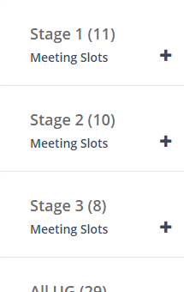

You can arrange a set of meeting timeslots that your students are able to sign up to. This is the online equivalent to the sheet of paper on the tutor’s door.

To create the slots, choose Tutoring from the drop down menu from the top of ePortfolio. You can split your students by programme or stage and use the ‘Create meeting slots for “Stage x” ‘to book slots for that stage or programme.

If you do not want to set up meeting slots for a stage or programme, use the Add Slots button.



The Meeting Slot Form

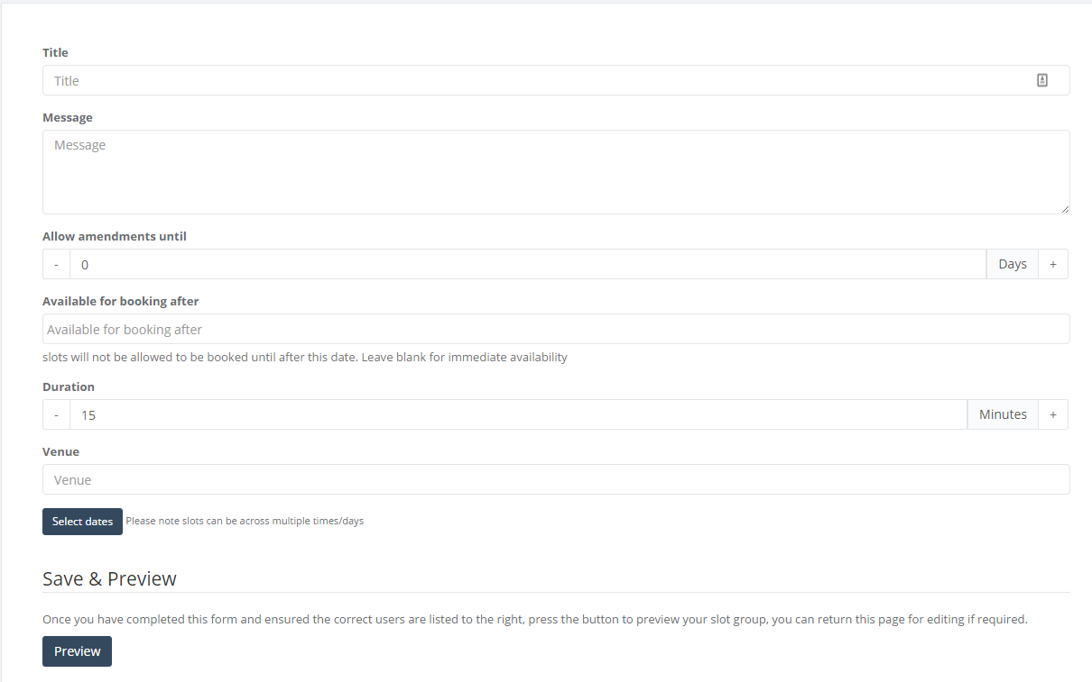

The meeting slot form will appear. Start at the top and fill out each section.

* Title and Message

Student will receive an email consisting of the title and message specified in the first section of the form.

* Allow amendments until

This relates to how soon to the start time of the slot a student can amend, deleted, or book on a slot.

* Available for booking after

What date is the slots open for students to book? Leave blank to allow them to book immediately.

* Duration

How long are you allowing for each slot?

* Venue

Where is the meeting to be held?

Use the ‘Select dates’ button to select the group of dates you wish to make available to students.

Once completed, click the Preview button. This will provide you with a useful summary of the slots your have created and who can access them. If you are satisfied that the summary is accurate, click ‘Confirm and Create Slots’. An email will be sent to the student from which they can access and book on the relevant slots. The tutor will receive an email notification when a tutee books on a slot.

Editing slots

You can edit meeting slots once they have been created. To access them, choose Meetings from the drop down menu, then List Meeting Slots from the panel on the left hand side. You will see a list of the various sets of meeting slots. You can click on the edit button to edit the slot set.

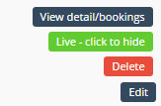

To edit individual slots, click on the name of the set of slots. The slots will appear in a pop up window. Use the edit button to the right of the slot to edit.