  - Recording a meeting with your tutor
To set up a meeting with your tutor, on the homepage click on the meeting button under your tutor’s image on the right of the screen.
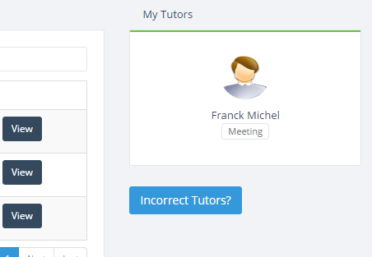

Complete the form with the date, time, venue, subject of meeting and any notes that you may wish to add before the meeting takes place.
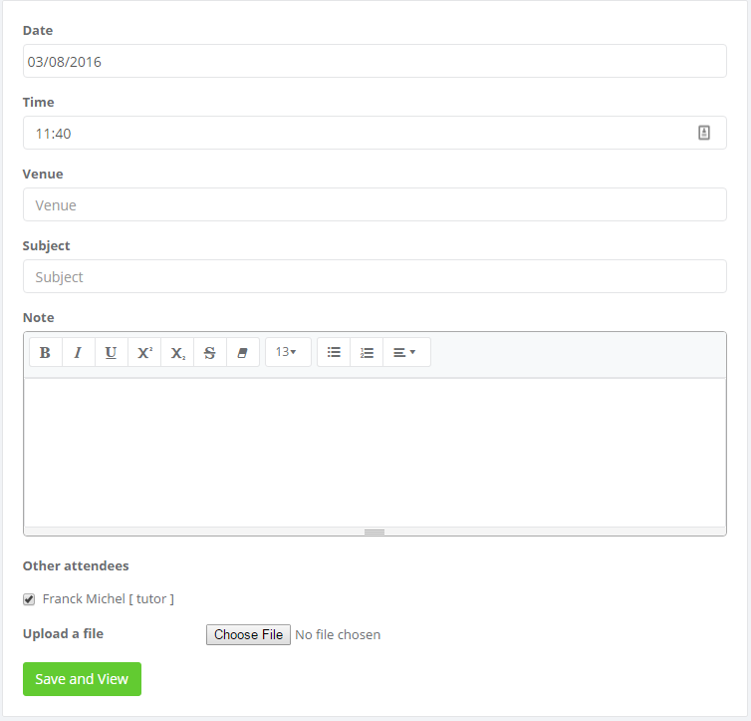

  - Adding Notes
You can add a note after the meeting has taken place. This could be in response to the meeting outcomes that your tutor has recorded. To do this, go to Meetings using the drop down list on the homepage. Click the view button to the right of the relevant meeting.
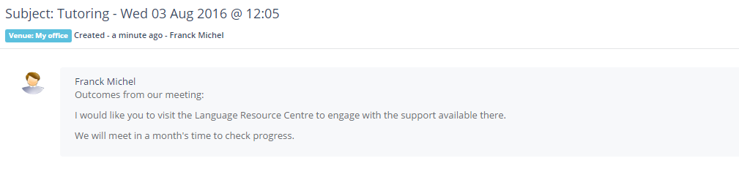
You can see any notes that your tutor may have added to the meeting record.

To add your note, click on the Add Note button. Fill in the details in the note. Remember that the notes you make will be read by all meeting attendees.
Think carefully about the language and tone that you use, to make sure that you express your thoughts clearly but without causing offence or distress.
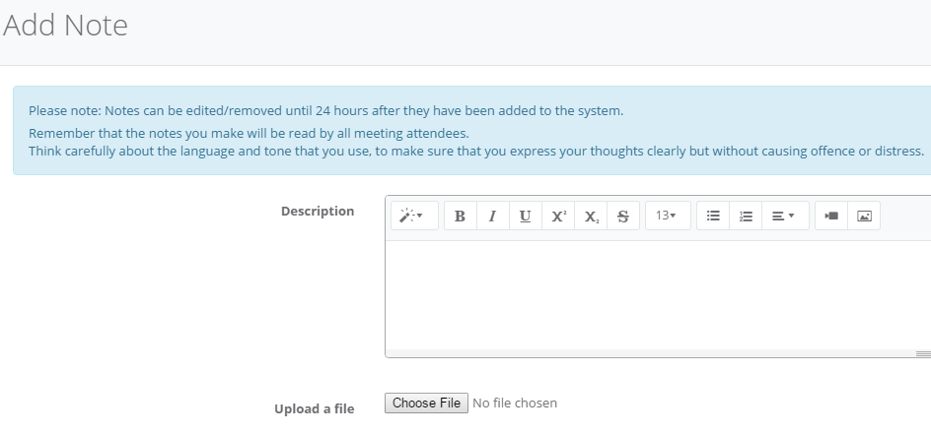
  - Meeting slots
Your tutor can set up some meeting slots that you can select from to book a meeting with them. You will receive an email if they have set up these slots.
When you receive the email, follow the link and it will take you through to the meetings page and give you a list of available slot groups.
To make a booking select ‘Make a booking’ on the slot group you wish to make a booking for.
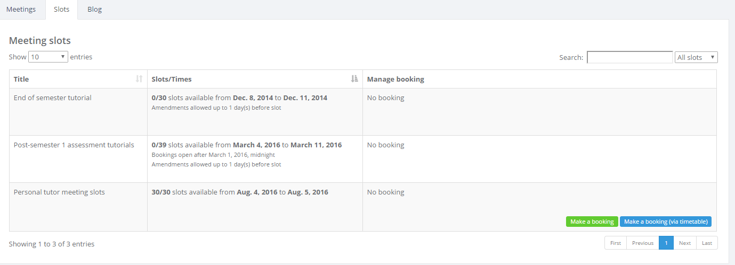
You will then be shown a list of possible timeslots, select which time you prefer and click ‘book’.
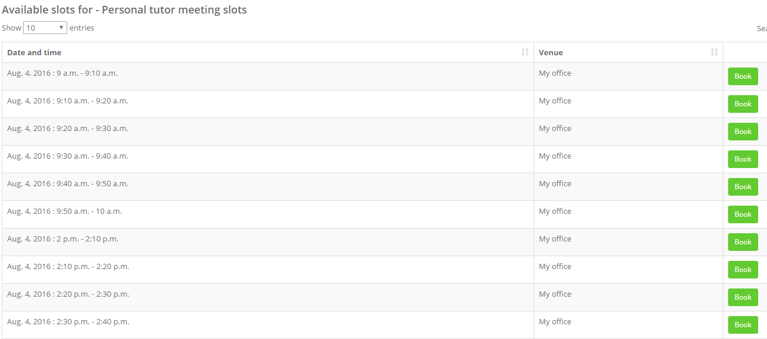
This will create a meeting inside ePortfolio, with you and your tutor as the attendees of that meeting.
  - Confidentiality
The notes of a tutor meeting are completely confidential. Any notes in a meeting in ePortfolio will only be able to be viewed by attendees of the meeting, unless the student permits someone else to view them. For more information about the confidentiality of meetings, please follow the link below.
https://portfolio.ncl.ac.uk/help/confidentiality

